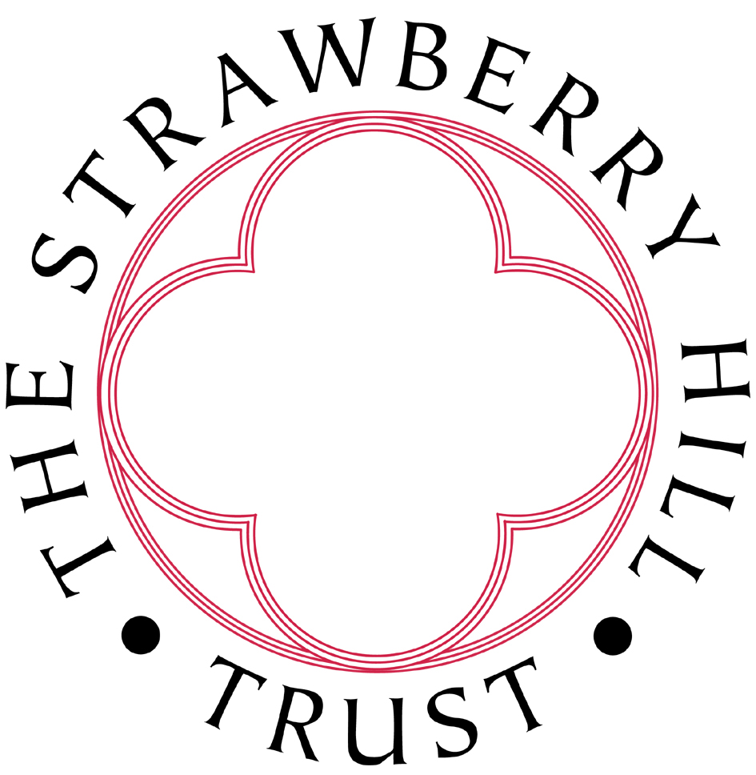

Case Study from Milly – Front of House, Conservation and Education Volunteer

What do you do at SHH?
At Strawberry Hill House I do an array of different things and within those roles, every day is different. I started off volunteering in the front of house role; welcoming guests, keeping the shop organised, checking visitors in and selling tickets. I then wanted to learn more about the ‘behind the scenes’ aspects to the house and so started to volunteer in the office organising education bookings for schools and other group visits. This admin role inspired me to also take part in the physical deliverance of school workshops which was so great! I really enjoy seeing the whole process of the children visiting the house. From organising what they will do when they arrive to helping them learn about the house through arts and crafts. I also am on the conservation team and have enjoyed the recent training session in learning the fine details of heritage conservation.

How long have you been volunteering here?
I have been volunteering at the House since November 2023.

What do you enjoy about your role here?
I love the people at Strawberry Hill. Front of house morning shifts are always such a laugh, you are with so many different people of different ages but everyone shares similar interests. Everyone in the office is so kind to me and I always feel very supported when I have any questions. The conservation training was very enjoyable, everyone in every capacity at Strawberry Hill is not afraid to get stuck in and help out.

Has volunteering at SHH helped you in any way?
Volunteering at the house has helped me so much to gain understanding of what I might like to do as a career. Working in heritage wasn’t on my mind when I moved to the area for university but now as an almost-graduate, that is the sector I am most excited to pursue a career in. Volunteering at the house has also allowed me to enrol in a few courses such as the Heritage Alliance carbon literacy course and courses run by Kids in Museums. Despite all the help that volunteering here has given me with fodder for my CV, it has given me a place to make many friends and to go when University life gets a bit overwhelming.

