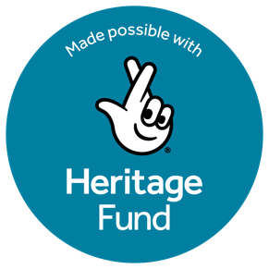

THE NEXT CHAPTER FOR STRAWBERRY HILL HOUSE AND GARDEN

Sixteen years after opening to the public, Strawberry Hill House and Garden is embarking on its next transformation - not just by restoring its walls, but by reimagining how people experience Britain's birthplace of the Gothic.
Thanks to a £242,000 award from The National Lottery Heritage Fund, Strawberry Hill Trust will launch an ambitious 12-month programme that will strengthen the House’s long-term resilience through vital conservation, improved visitor access, investment in digital infrastructure, expanded learning opportunities and innovative cultural programming.
The Heritage Fund support will help Strawberry Hill build on the success of its landmark restoration by investing in the future of one of Britain’s most important historic houses. Key projects include the conservation and improved access to the projecting Oriel Window in the Round Room, one of the House’s defining architectural features, together with investment in digital systems to transform public access to museum collections and research resources. The programme will also fund an architectural feasibility study to explore improved visitor arrival, orientation, and navigation across the Grade I listed House and its Grade II* listed gardens.

The programme will invest not only in the historic fabric of the House but also in the people who will shape its future. Working in partnership with neighbouring St Mary's University, Strawberry Hill Trust will pilot a heritage internship programme, providing more than twenty students with hands-on experience in audience research, visitor engagement and heritage management, helping to develop the next generation of museum professionals.

Alongside this, a new Cultural Programmer will develop and evaluate ambitious public experiences designed to broaden audiences and strengthen the Trust's long-term sustainability. These include the expansion of the popular Strawberry Hill Flower Festival in September 2026 from 3 to 4 days and with an upscaled events programme, together with the development of a pilot Festival of the Gothic Imagination anchored by World Goth Day (22 May 2027), combining the visual and performing arts with literary events. For the 2026 Flower Festival programme please see the House and Garden website Strawberry Hill House Flower Festival 2026 - Strawberry Hill House & Garden

Dr David Gaimster, Executive Director of Strawberry Hill Trust, said: “We are incredibly grateful to The National Lottery Heritage Fund for its generous support. As an independent heritage charity, this funding makes it possible for us to preserve this extraordinary national treasure for future generations, to transform digital access, explore improvements to the visitor arrival and circulation and diversify our staffing and audiences through piloting and rigorous evaluation. Strawberry Hill House and Garden has only operated as a visitor attraction for 16 years. With the Heritage Fund’s support, we can now plan with confidence for the next 16 years of development.”
Stuart McLeod, Director of England - London & South at The National Lottery Heritage Fund, said: “Strawberry Hill House and Garden holds a unique place in the UK’s heritage as the birthplace of the Gothic revival and we’re delighted to support its exciting next chapter. This project not only safeguards its fabric but also reimagines how people can experience and engage with its stories. Crucially, it invests in people too, creating opportunities for young people and future heritage professionals. Thanks to National Lottery players, we’re proud to be supporting this project that will ensure Strawberry Hill continues to inspire and welcome audiences for many years to come.”

NOTES FOR EDITORS

Image Downloads and Credit
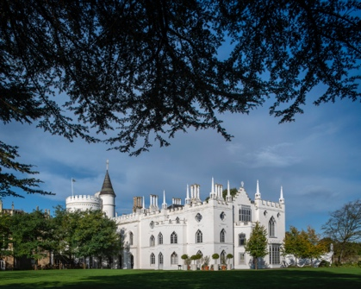
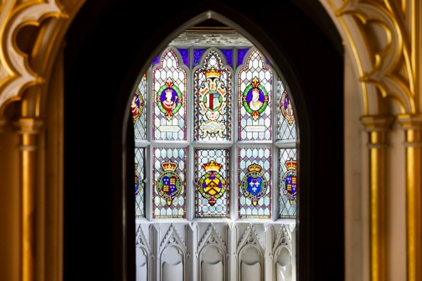
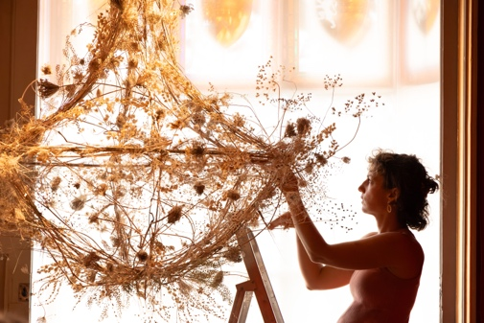
High-resolution images for media use can be downloaded via Dropbox.

About Strawberry Hill House and Garden
The Strawberry Hill Trust was formed as a registered charity in 2002 to restore and operate Strawberry Hill House and Garden, Horace Walpole’s unique Grade One listed “Little Gothic Castle” in Twickenham, London. Our Vision & Mission - Strawberry Hill House & Garden

The high-profile restoration was successfully completed, and Strawberry Hill opened to the public in 2010 as a heritage visitor attraction. 16 years on, Strawberry Hill has built an international and intergenerational audience, who are passionate about Strawberry Hill and inspired by what it represents. In 2025, over 25,500 visitors came from all over the world with a further 4 million global online visitors.

Strawberry Hill House and Garden is internationally important as one of the first and most influential Gothic Revival landmarks with a lasting impact as a building on architecture and design and on the wider cultural landscape. Created between 1747 and 1792 by Horace Walpole, the historian, antiquarian and son of Britain’s first Prime Minister, Sir Robert Walpole, the grade one listed House is regarded as the birthplace of the Gothic Imagination, an enduring worldwide cultural phenomenon in all forms of art, architecture and literature. Strawberry Hill House and Garden is now an Arts Council accredited museum, displaying significant items from Walpole’s original art collection and other important objects from subsequent owners on permanent or temporary display. The public programme includes talks, exhibitions and tours to interpret the continuing influence and relevance of the Gothic for our visitors each year, plus a curriculum linked education programme for schools and a strong volunteer programme with many different roles for over 200 volunteers across the House and Garden.
For press enquiries, interviews and images, please contact: press@strawberryhillhouse.org.uk

About The National Lottery Heritage Fund
Our vision is for heritage to be valued, cared for and sustained for everyone, now and in the future. That’s why as the largest funder for the UK’s heritage we are dedicated to supporting projects that connect people and communities to heritage, as set out in our strategic plan, Heritage 2033. Heritage can be anything from the past that people value and want to pass on to future generations. We believe in the power of heritage to ignite the imagination, offer joy and inspiration, and to build pride in place and connection to the past.
Over the next 10 years, we aim to invest £3.6billion raised for good causes by National Lottery players to make a decisive difference for people, places and communities.
heritagefund.org.uk
Please follow and tag @HeritageFundUK on Instagram, Facebook, LinkedIn and YouTube and use the hashtags #HeritageFund #NationalLottery

